1. Prompt for amount, interest rate and no. of years and calculate simple interest.

Ans== <https://github.com/pranav0297/js-/blob/main/simple_interest.html>

<https://github.com/pranav0297/js-/blob/main/simple_interest.js>

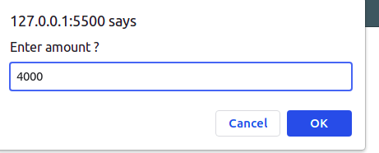

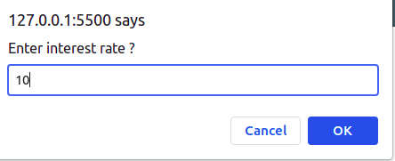

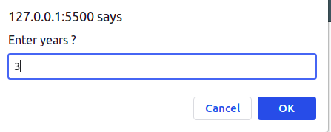

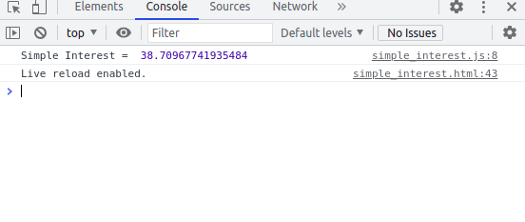

1. is palindrome string

Ans == <https://github.com/pranav0297/js-/blob/main/palindrome.html>

<https://github.com/pranav0297/js-/blob/main/palindrome.js>

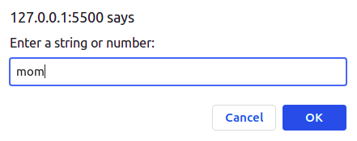

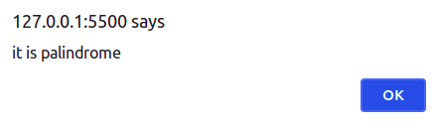

1. Area of circle

Ans == <https://github.com/pranav0297/js-/blob/main/circle_area.html>

<https://github.com/pranav0297/js-/blob/main/circle_area.js>

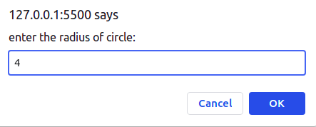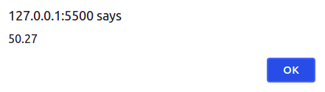

1. Copy information of one object to another and log it to console.

Ans == <https://github.com/pranav0297/js-/blob/main/copy_obj.html>

<https://github.com/pranav0297/js-/blob/main/copy_obj.js>

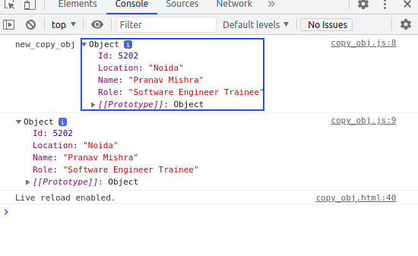

1. create a list of objects of Employee with info as follow :
   * Name, age, salary ,DOB
   * filter all employees with salary greater than 5000
   * group employee on the basis of their age
   * fetch employees with salary less than 1000 and age greater than 20. Then give them an increment 5 times their salary.

Ans == <https://github.com/pranav0297/js-/blob/main/employee.html>

<https://github.com/pranav0297/js-/blob/main/employee.js>

